**Name:** Aldaine Clarke

**Course:** Front End Development (AMBER)

**Project Title:** Pediatric Hospital of Jamaica.

**Due Date:** August 31, 2022

Table of Contents

Project Introduction 3

Problem Statement 4

Limitations 5

Code and Screenshots 6

Home Page 6

Output of Hero Section with Booking Form 6

Implementation of Appointment Booking Form 6

Appointment Controller 7

Testing Booking Request to Appointments 8

News Section Output 8

Implementation of News Section 9

Service to interact with API 9

Admin Login page 10

Output of Login Page 10

Implementation of Login Page 11

Technical Documentation 13

# Project Introduction

The purpose of the final project is aimed at ascertaining the level of competency you have in

software development using the Angular framework and the other assistive software

development technologies that you have learned throughout the practical application of this

course. You will be required to identify a problem from within a list of categories of which you will be provided. It is required that you design and develop the application or suite of applications to solve the specific problem incorporating the software development tools that you have been exposed to over the duration of the training period.

# Problem Statement

The requirement was to create an application that allows a pediatric medical care centre to properly manage the patients and staff that they have available.

The **Minimum Viable Product (MVP)** of the system is that, it should allow users to create an appointment to see the doctors available. The hospital staff should be able to manage all the appointments that are made, and should also be able to create an appointment, in the case where the user decides to call in to set appointment. To ensure authorization on who can manage the system, there will be a login system for the admin section of the application.

The vision of this project is to create a Management System to assist medical care facilities with features that will expedite the processes of its regular day to day operation. Some of these features are the management of Doctors, Inventory, Patients, Medical Records.

# Limitations

The major limitation for this ambitious project, is the time frame that was required to complete the project. While the base requirement for this project may be simple, as it should be for a project of such a small time frame, I couldn’t neglect the possibility of the project scaling up.

Additionally, I have considered the possibility of this being a necessary application for a medical facility, as I have been in a situation where I have been inconvenienced because of the medical care facility’s processes. It is because of these reasons that I have decided to take this route and do this ambitious project.

I plan to continue working on the project even after submission to have a working prototype as soon as possible.

# Code and Screenshots

## Home Page

### Output of Hero Section with Booking Form

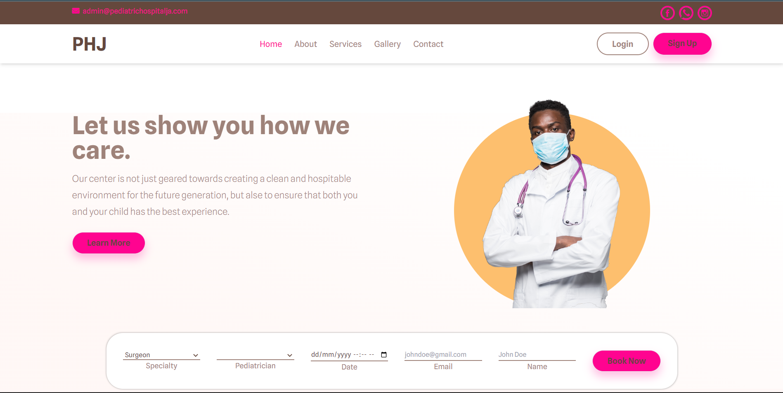

### Implementation of Appointment Booking Form

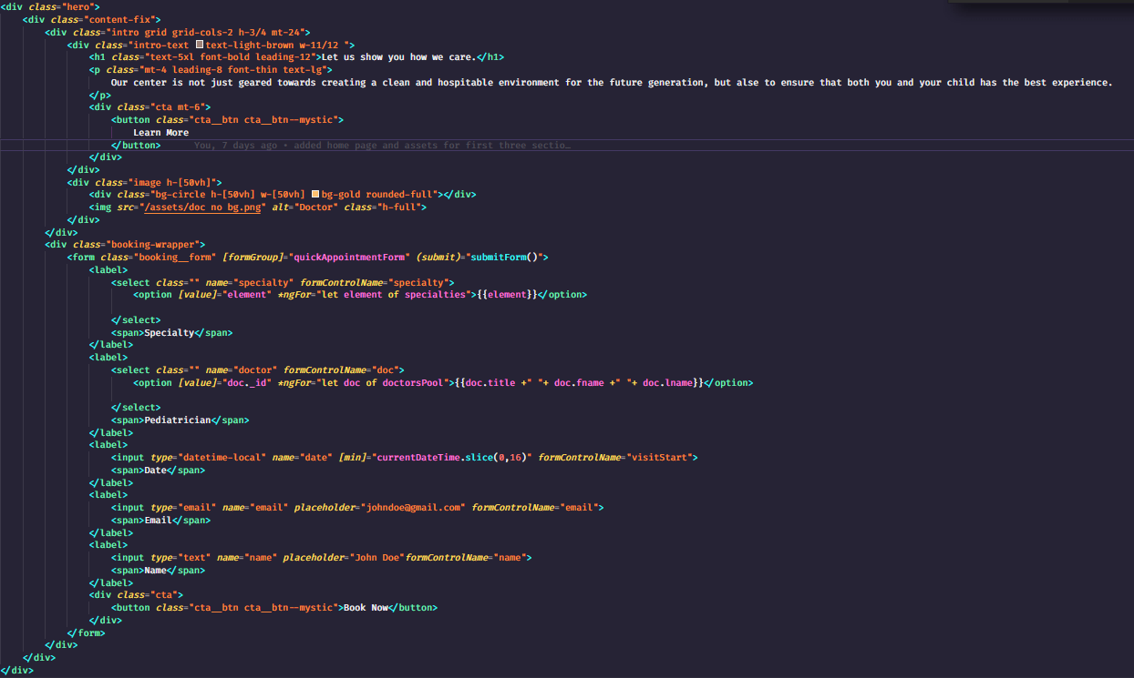

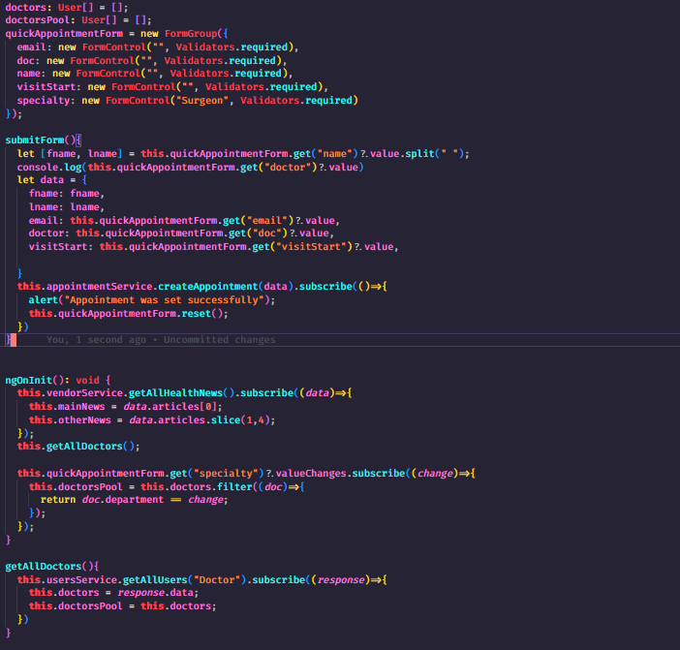

### Appointment Controller

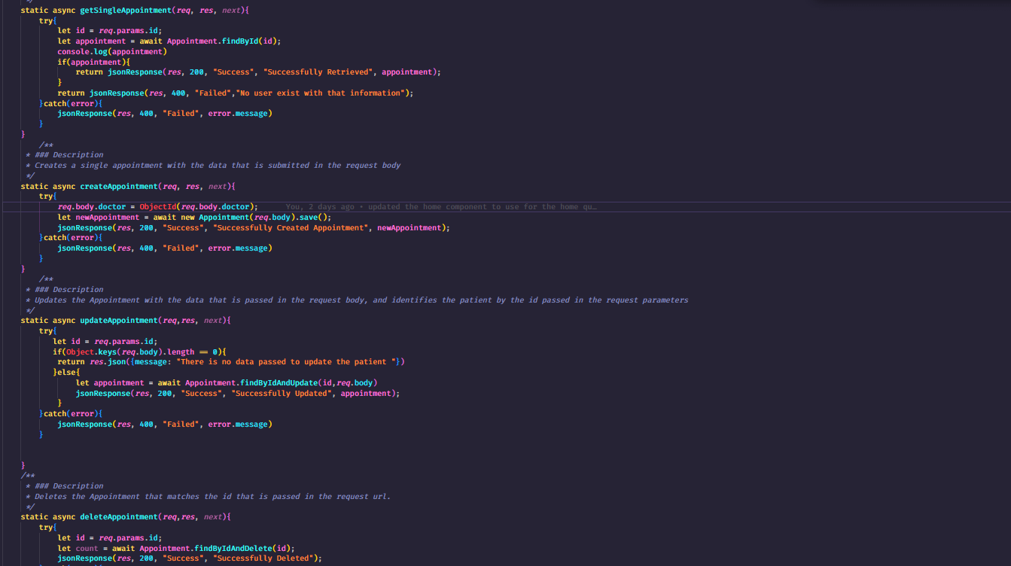

### Testing Booking Request to Appointments

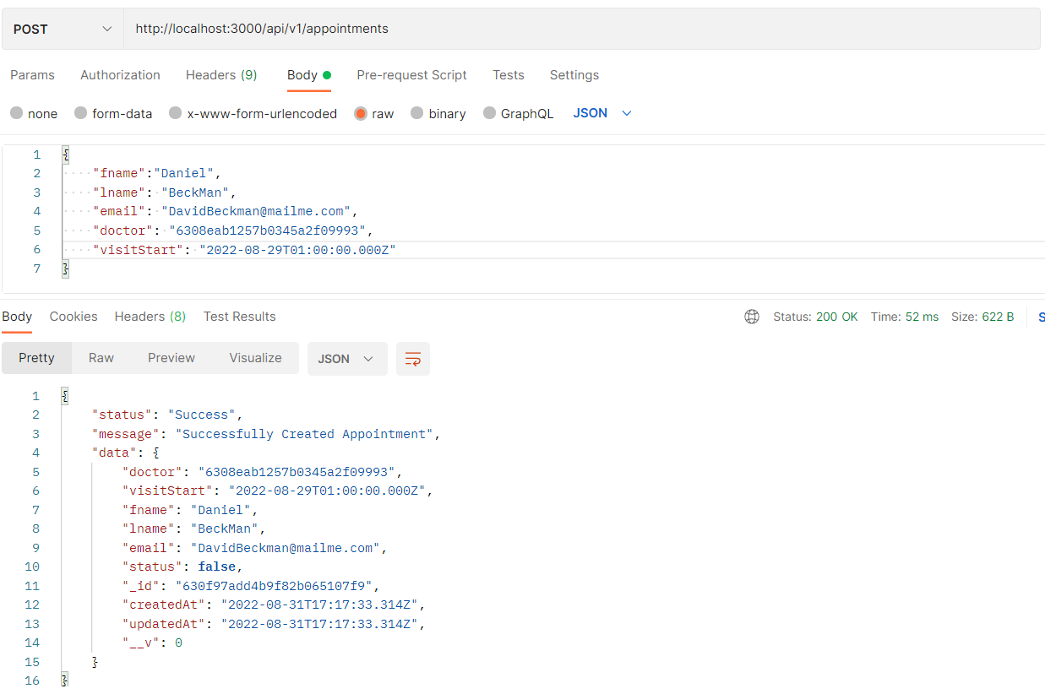

### News Section Output

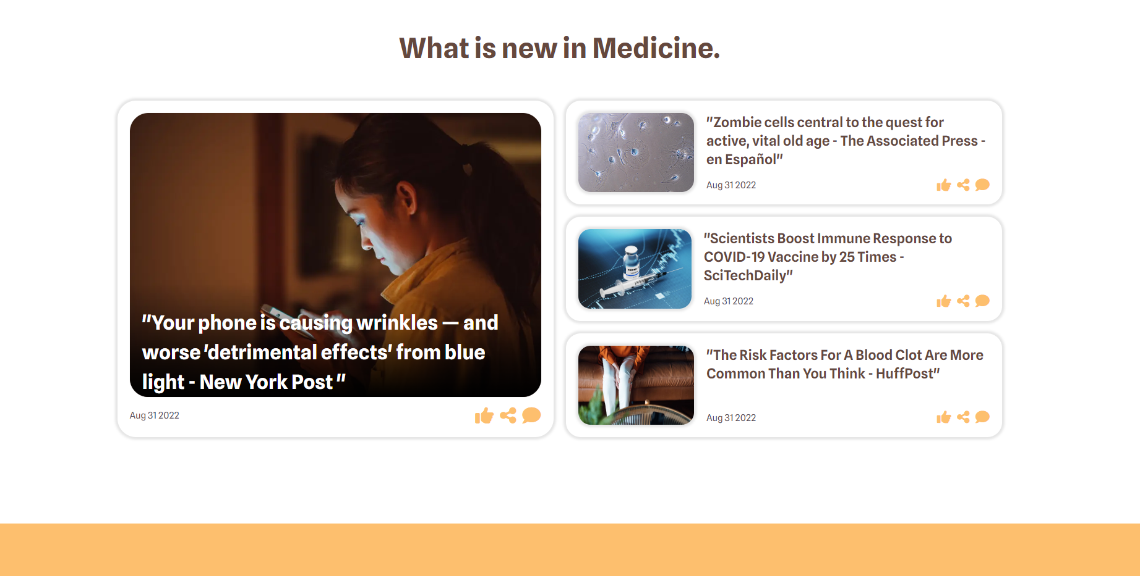

### Implementation of News Section

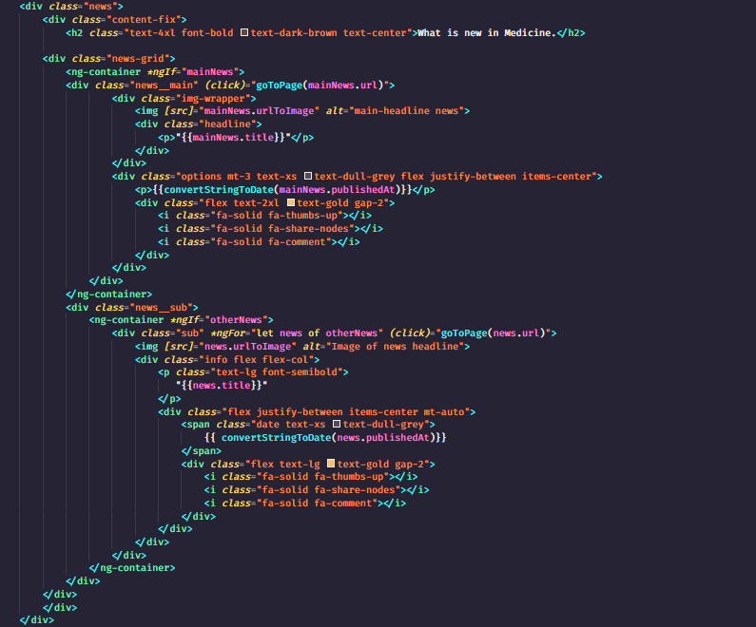

### Service to interact with API

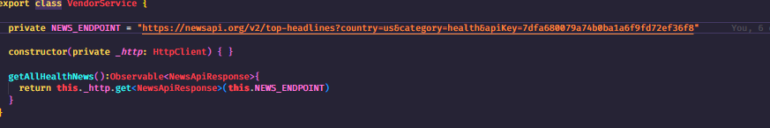

### API Testing News API

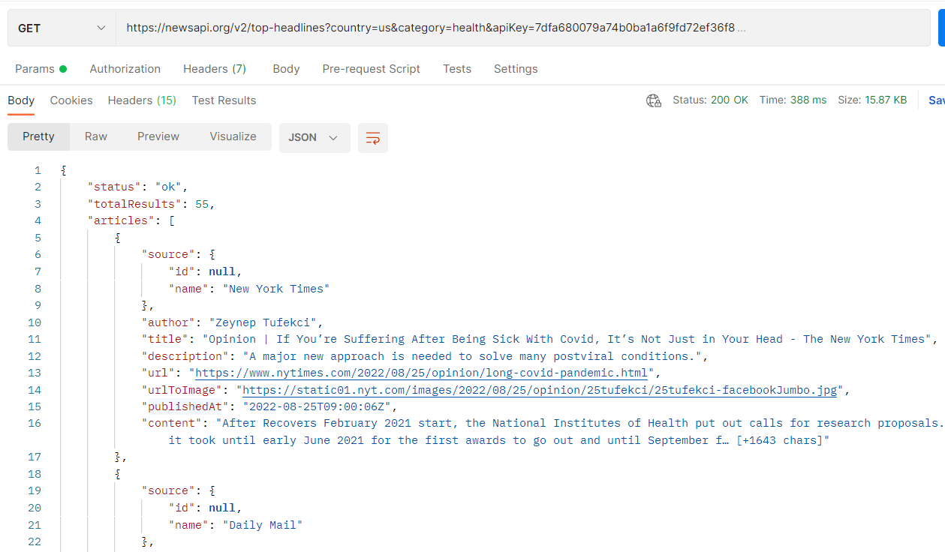

## Admin Login page

### Output of Login Page

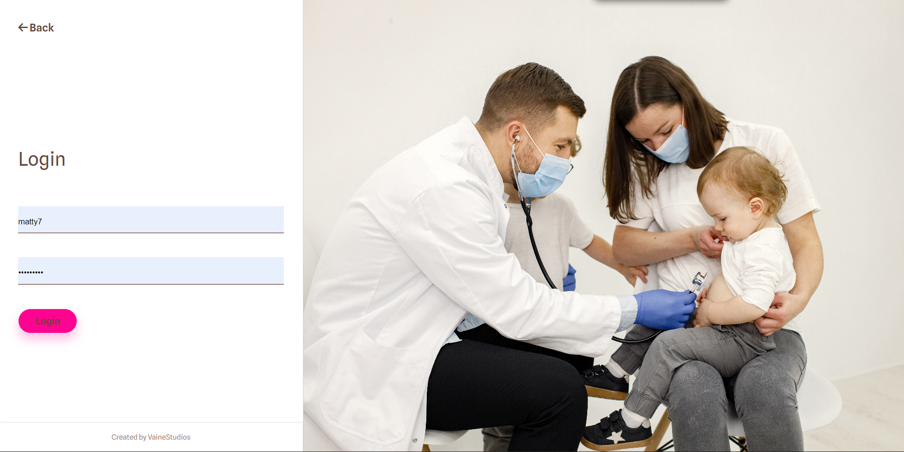

### Implementation of Login Page

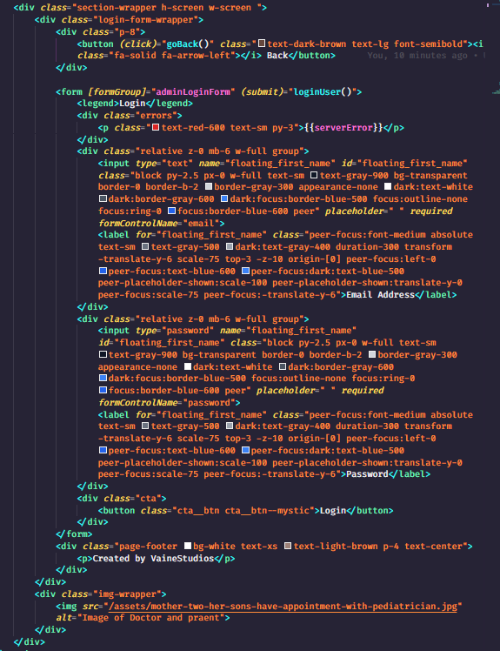

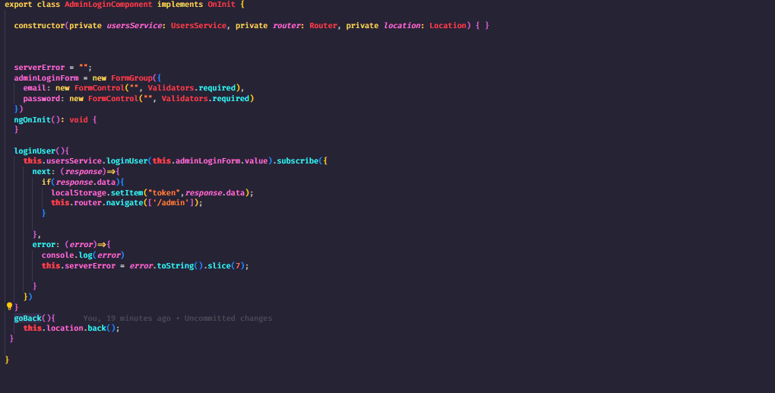

### Users Controller Login

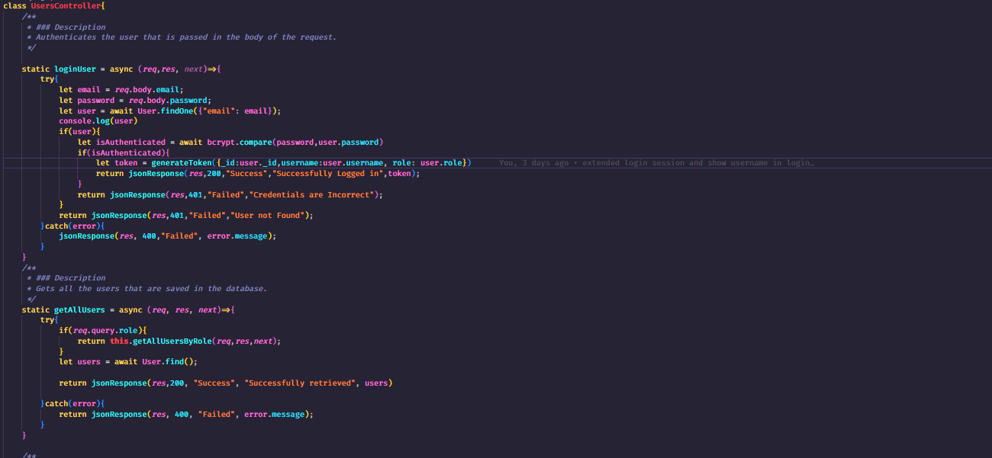

.

### API Testing Login

### 

## Admin Appointments Page

### Output of Admin Appointment’s Page

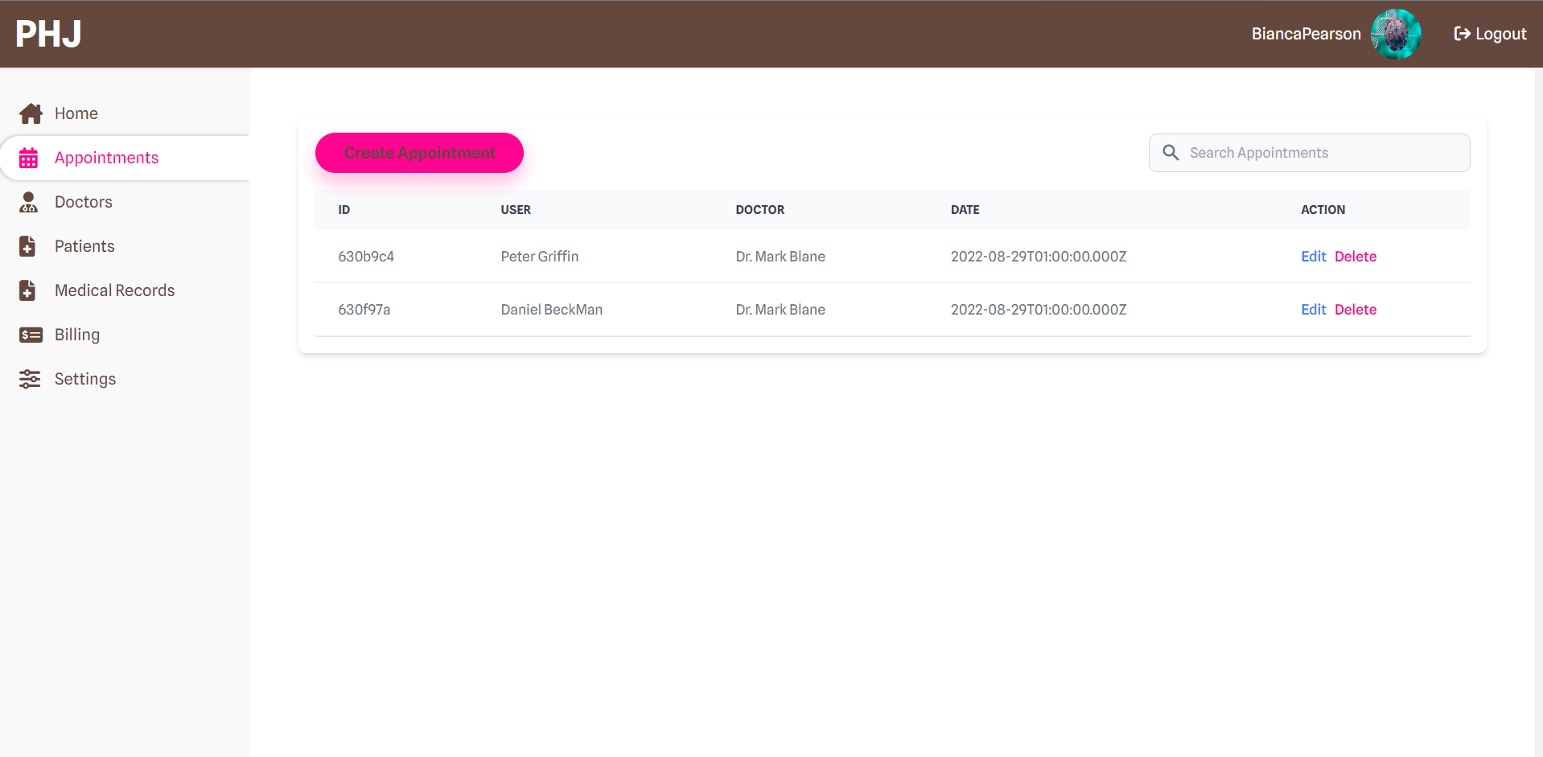

# Technical Documentation

The application Pediatric Hospital of Jamaica, is a full stack application built with the MEAN tech stack. This means it incorporates MongoDB for the Database, Express for the server Angular for the Frontend and Node, which is used as a platform to run each technology.